DESIGN AND IMPLEMENTATION OF
STUDENT INFORMATION SYSTEM

Table description:
Form1: student details
Name Null? Type
----------------------------------------- -------- ------------------
ROLLNO NUMBER(10)
NAME VARCHAR2(10)
DEPT VARCHAR2(3)
SEM VARCHAR2(3)

Form1: mark details

Name Null? Type
----------------------------------------- -------- ----------------------------
ROLLNO NUMBER(5)
NAME VARCHAR2(10)
DEPT VARCHAR2(4)
MARK1 NUMBER(3)
MARK2 NUMBER(3)
MARK3 NUMBER(3)
AVERAGE NUMBER(7)

Form design:
Form1: Student detail

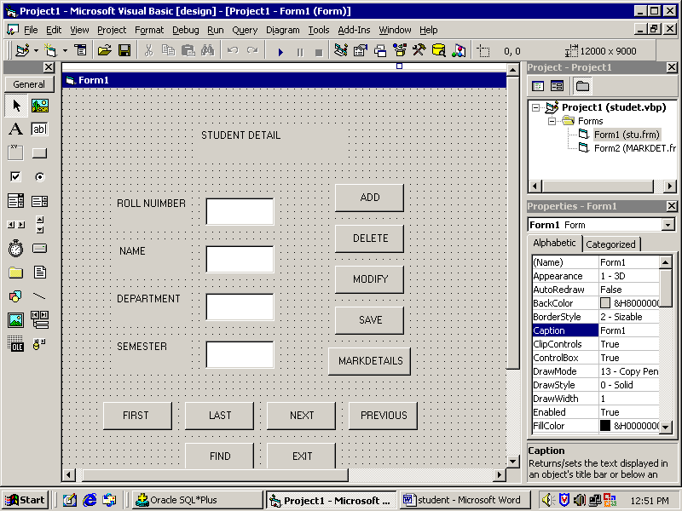

Form2: Mark detail

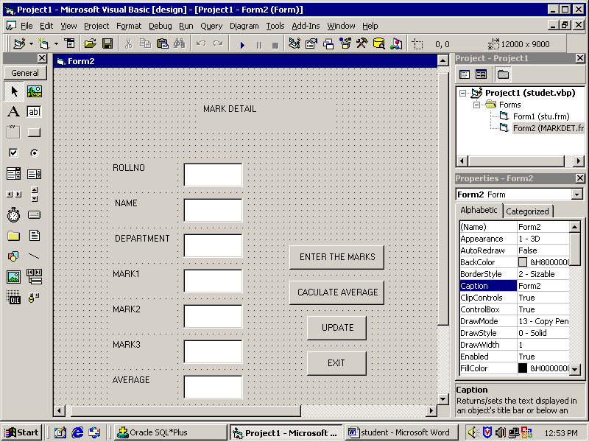

Coding: FORM1

Dim con As New ADODB.Connection
Dim rs As New ADODB.Recordset

Sub clear()
Text1.Text = ""
Text2.Text = ""
Text3.Text = ""
Text4.Text = ""
End Sub

Sub display()
Text1.Text = rs(0)
Text2.Text = rs(1)
Text3.Text = rs(2)
Text4.Text = rs(3)
End Sub

Private Sub Command1_Click()
clear
Text1.SetFocus
End Sub

Private Sub Command11_Click()
Unload Me
End Sub

Private Sub Command2_Click()
rs.Delete
MsgBox "record deleted"
rs.MoveNext
display
End Sub

Private Sub Command3_Click()
rs(0) = Text1.Text
rs(1) = Text2.Text
rs(2) = Text3.Text
rs(3) = Text4.Text
rs.Update
MsgBox "record modified"
End Sub

Private Sub Command4_Click()
rs.MoveLast
rs.AddNew
rs(0) = Text1.Text
rs(1) = Text2.Text
rs(2) = Text3.Text
rs(3) = Text4.Text
rs.Update
display
MsgBox "Record updated"
clear
End Sub

Private Sub Command5_Click()
Form2.Show
End Sub

Private Sub Command6_Click()
rs.MoveFirst
display
End Sub

Private Sub Command7_Click()
rs.MoveLast
display
End Sub

Private Sub Command8_Click()
rs.MoveLast
If rs.EOF = True Then
rs.MoveFirst
display
Else
display
End If
End Sub

Private Sub Command9_Click()
rs.MovePrevious
If rs.BOF = True Then
rs.MoveLast
display
Else
display
End If
End Sub

Private Sub Command10_Click()
Dim w As Integer
w = InputBox("enter the rollno number")
On Error GoTo er
rs.Find "rollno=" & w, , adSearchForward
display
Exit Sub
er:
clear
MsgBox "record not found"
End Sub

Private Sub Form_Load()
con.Open "stu", "scott", "tiger"
rs.Open "select * from studen", con, adOpenDynamic, adLockPessimistic
rs.MoveFirst
End Sub

Coding: FORM2

Dim con, con1 As New ADODB.Connection
Dim rs, rs1 As New ADODB.Recordset

Sub clear()
Text4.Text = ""
Text5.Text = ""
Text6.Text = ""
Text7.Text = ""
End Sub

Sub display()
Text1.Text = Form1.Text1.Text
Text2.Text = Form1.Text2.Text
Text3.Text = Form1.Text3.Text
Text4.Enabled = False
Text5.Enabled = False
Text6.Enabled = False
Text7.Enabled = False
End Sub

Private Sub Command1_Click()
Text1.Text = Form1.Text1.Text
Text2.Text = Form1.Text2.Text
Text3.Text = Form1.Text3.Text
Text4.Enabled = True
Text5.Enabled = True
Text6.Enabled = True
Text4.SetFocus
End Sub

Private Sub Command2_Click()
Text7.Enabled = True
Text7.Text = (Val(Text4.Text) + Val(Text5.Text) + Val(Text6.Text)) / 3
End Sub

Private Sub Command3_Click()
Set rs1 = New ADODB.Recordset
rs1.Open "mark", con, adOpenDynamic, adLockPessimistic
rs1.AddNew
rs1(0) = Val(Text1.Text)
rs1(1) = Text2.Text
rs1(2) = Text3.Text
rs1(3) = Val(Text4.Text)
rs1(4) = Val(Text5.Text)
rs1(5) = Val(Text6.Text)
rs1(6) = Val(Text7.Text)
rs1.Update
MsgBox "updated"
rs1.Close
clear
Text1.Text = ""
Text2.Text = ""
Text3.Text = ""
End Sub

Private Sub Command4_Click()
Unload Me
End Sub
Private Sub Form_Load()
Set con = New ADODB.Connection
Set rs = New ADODB.Recordset
con.Open "stu", "scott", "tiger"
rs.Open "select * from studen", con, adOpenDynamic, adLockPessimistic
display
clear
End Sub

Output screen shots:

Student detail

Save

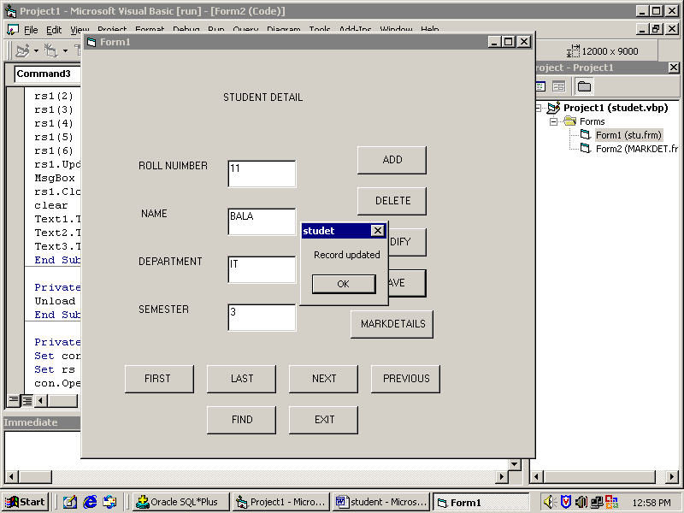

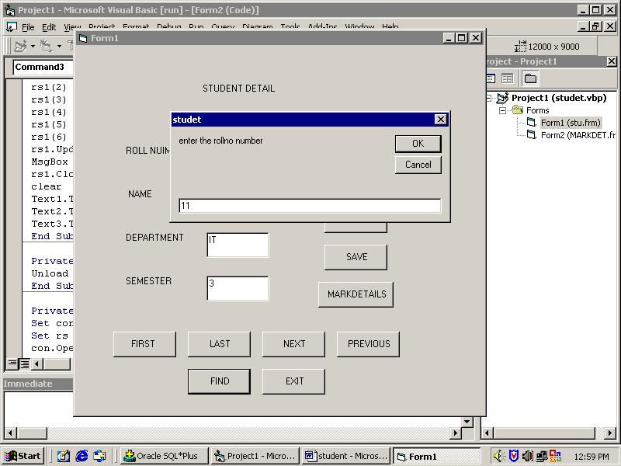
Find

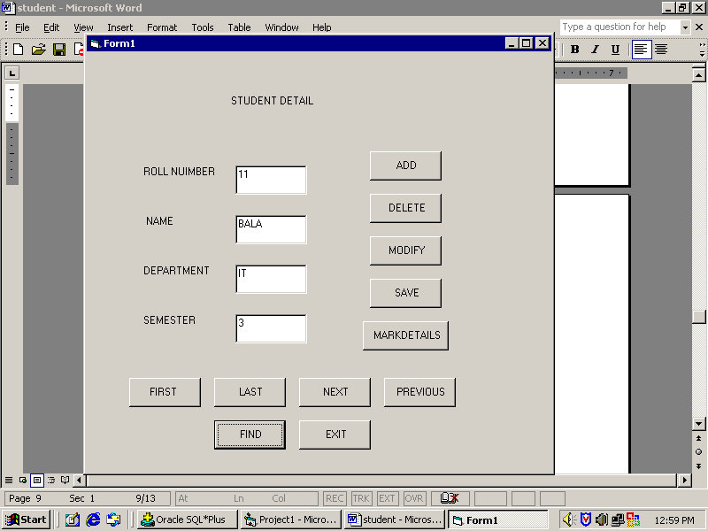

Modify

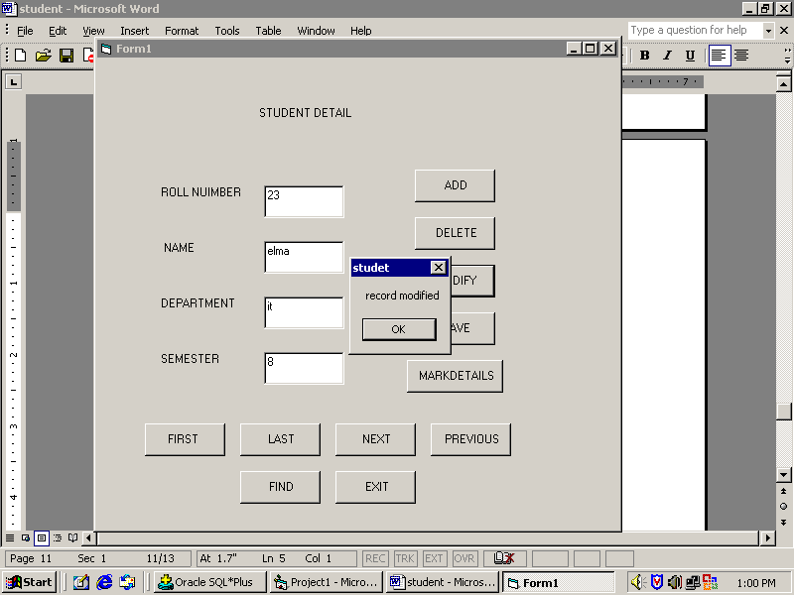

Delete

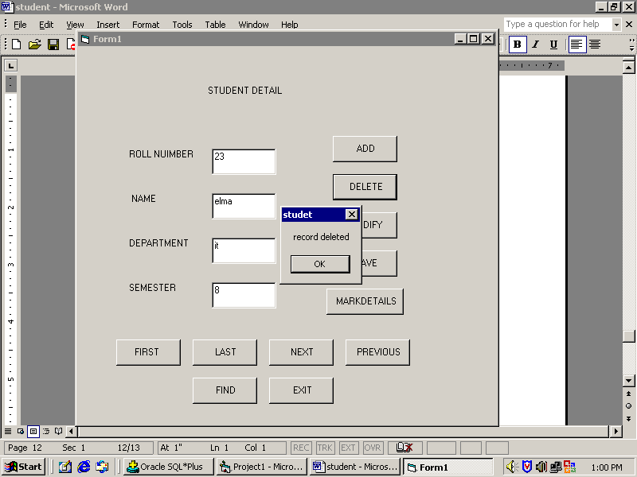

Mark detail screen shots

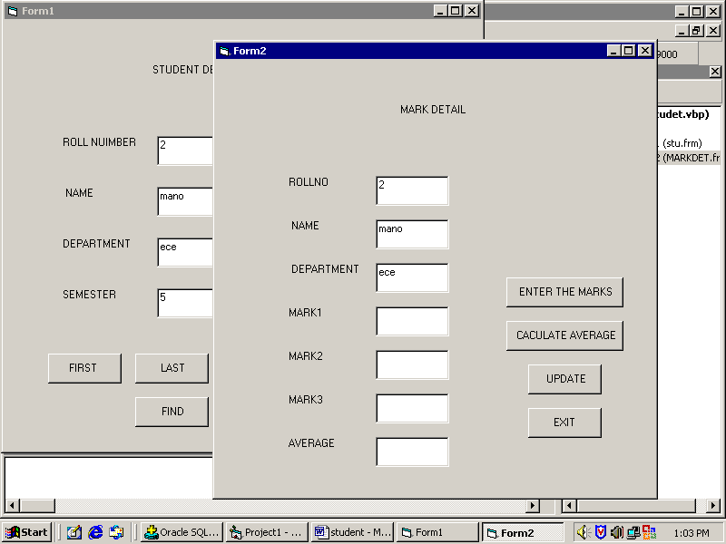

Calculate Average

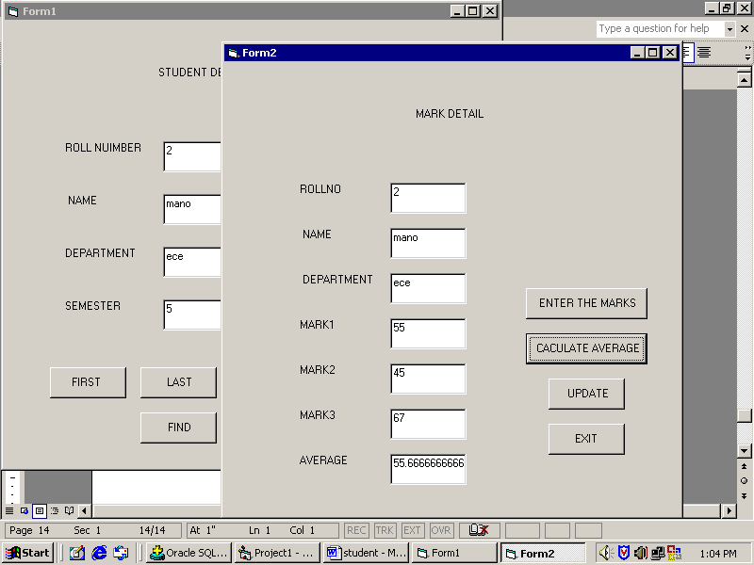

Update

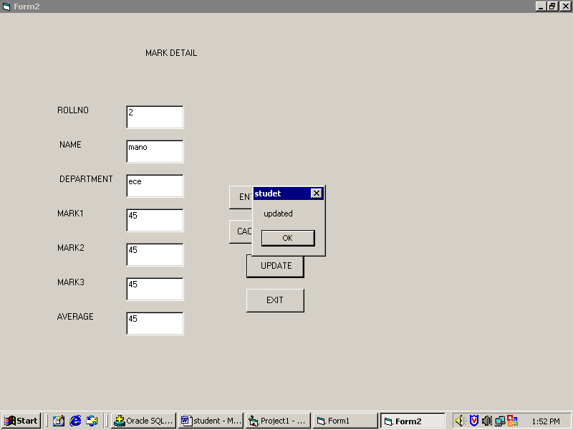

Result:

Thus the VB program was executed and employee information was retrieved successfully.

